VIRTUAL SOC CAPSTONE

MEETING NOTES #1
04 SEPTEMBER 2025 / 5:45 PM

ATTENDEES
Dr. Walden & Capstone Group

AGENDA
- Introductions?
- Questions
  - Timeline? How should we begin?
  - What should we put in our git repo? How should we manage it?
    - Network diagrams, notes, lab notebook (setting stuff up, helpful for eventual scripted deployment)
  - What if something goes wrong on an openstack instance, are we able to revert/change management process?
    - Snapshot capabilities
  - Suggestions for dividing work?
    - Teams of 2
  - Agile? Sprints?
    - 4 week sprint until the 30th?
    - Firewall/NIDS team,

NOTES
- Start with NIDS once we have the infrastructure set up
- Teams of 2
- NIDS will be its own machine
- By the end of September, be able to observe traffic on the NIDS
- Start all systems on linux so we dont have to deal with Windows license
- First checkpoint, no DMZ
- First version: kali (External), pfsense FW, NIDS(pfsense)/victim (sep 30th)
- For the next meeting, have lab notebooks prepared showing everything you’ve done/experimented with
- Capstone Lecture 9/4
  - We will still need instructor meetings every 2 weeks. Schedule this through her calendar
  - See rubric for instructor meetings on slides
  - Will need kanban board
  - Milestone chart

ACTION ITEMS
- Remake mermaid diagram to more accurately display architecture
- Virtualbox experimentation with kali -> NIDS (pfsense) until we get openstack access

- 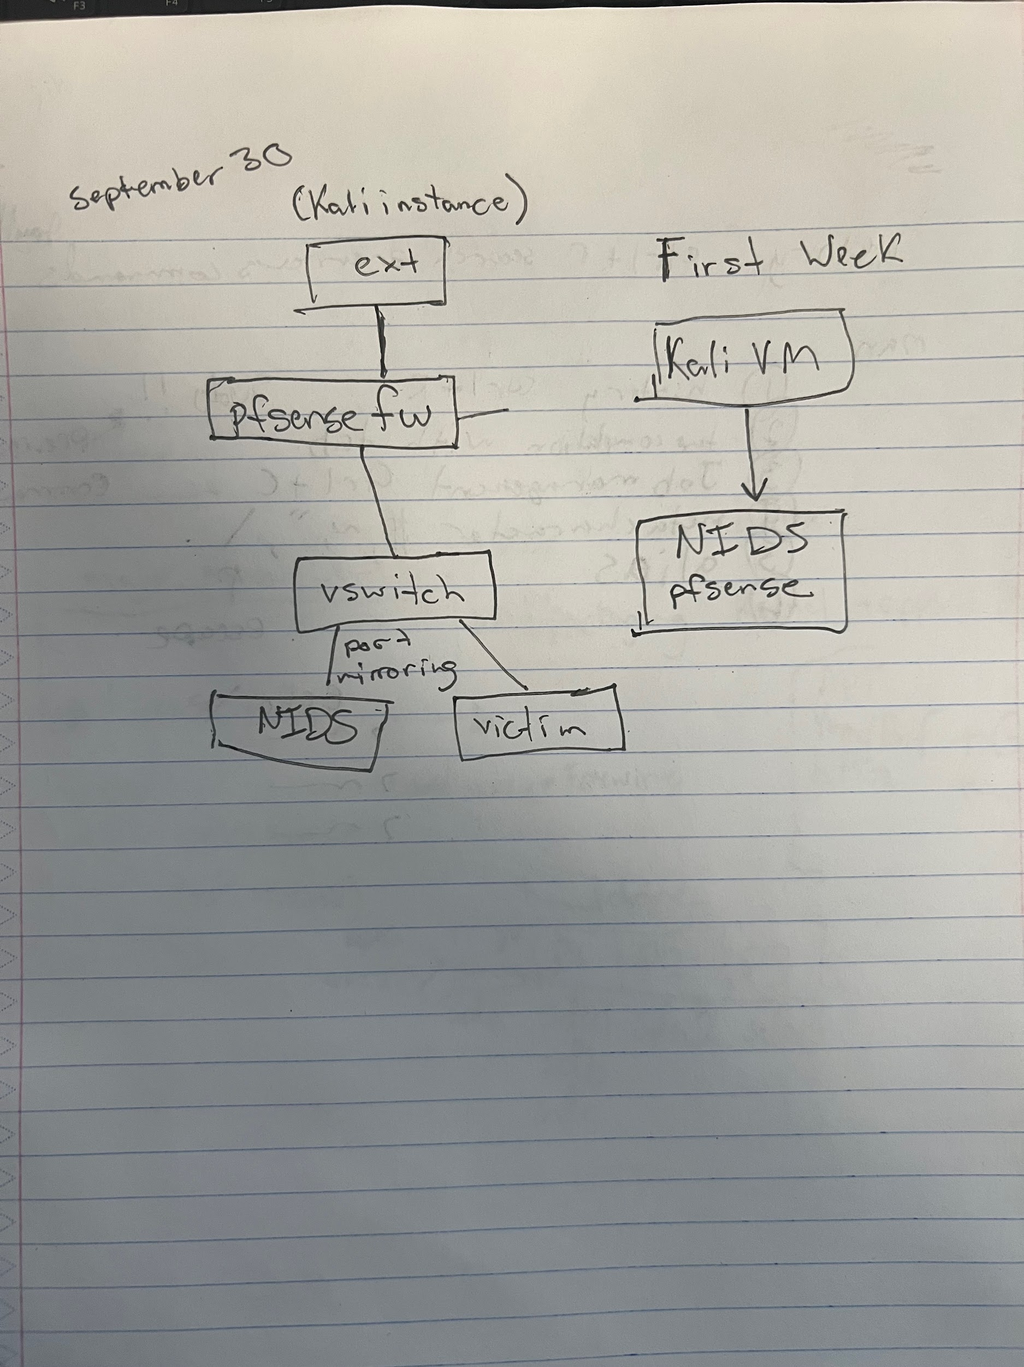

NEXT WEEK’S AGENDA
- Next meeting date?
- (for evan) ask about cyber club meeting next week

